

Centre Name: ACE-HCMC-2-FPT.

Address: 590 Cach Mang Thang 8, District 3, Ho Chi Minh City, Viet Nam.

**Webster**

Online - Aptitude Test

|  |  |  |
| --- | --- | --- |
| **Supervisor:** | TRẦN PHƯỚC SINH | |
| **Semester:** | 3 | |
| **Batch No:** | T1. 2008.A0 | |
| **Group No:** | 1 | |
| **Order:** | **Full name** | **Roll No.** |
| 1. | Nguyễn Ngọc Thiện | Student1275248 |
| 2. | Lê Nguyễn Thành Nhân | Student1277226 |
| 3. | Lê Hữu Tâm | Student1270662 |
| 4. | Phạm Viết Vương | Student1073134 |

**Month**: 12 **Year**: 2021



This is to certify that

|  |  |
| --- | --- |
| **Mr.** | **Nguyễn Ngọc Thiện** |
| **Mr.** | **Lê Nguyễn Thành Nhân** |
| **Mr.** | **Lê Hữu Tâm** |
| **Mr.** | **Phạm Viết Vương** |

Have successfully Designed & Developed

|  |  |  |
| --- | --- | --- |
|  |  |  |
| **Webster – Online Aptitude** | | |

Submitted by:

|  |
| --- |
| **Mr. TRAN PHUOC SINH** |

Date of Issue:

|  |  |
| --- | --- |
|  |  |

Authorized Signature:

|  |  |
| --- | --- |
|  |  |

Contents

Acknowledge 6

Introduction 6

Project Objectives 7

Problem Definition 7

Data Processing 8

From user 8

Input 8

Output 8

From Admin 8

Input 8

Output 8

Customer Requirement Specification 9

Functional Requirement Specifications 10

User Functionality: 10

Admin Functionality: 10

Hardware/ Software Requirements 11

Hardware 11

Software 11

Task Sheet review 1 12

Architecture & Design of the project 14

Algorith - Data Flowchart 15

Symbol: 15

Main data flowchart for users 16

Login Process (for admins & users) 17

Logout Process (for admins & users) 17

Insert User (for admins & users) 17

Update user’s information (for admins & users) 18

Create Exam (for admins) 18

Create Question Group (for admins) 18

Use Case Diagram 19

Admin 20

Entity Relation Diagram 21

Task Sheet review 2 22

Database Design 24

Site map 28

Source code structure 29

Connection string 29

GUI Design 30

1.1 Homepage 30

2.1 Online-Test Interface - Admin 33

2.2 Online-Test Interface – Candidate 35

3.1 Admin Pages 39

Task Sheet review 3 45

**Review 1**

# Acknowledge

We would like to express our special thanks of gratitude to our teacher Tran Phuoc Sinh as well as Aptech who gave us the opportunity to do this wonderful project. We are thankful for the opportunity to increase our knowledge and fortified our skills on the subject of website development. We acknowledge this project was designed to advance our future prospect.

# Introduction

The Webster organization is the leading organization in the world of Oil-Gas Company. They have various branches throughout the world. It has various bonds with different multi-national company. The company wants an application to be built for the jobseeker where the entire candidate as per to the criteria will appear for the online test and based on the result of this the candidate will go for further rounds.

# Project Objectives

The objective of this program is a functional web application which meet the requirement of a simple to use, ease of access for a user to find available vehicle for rent, registering vehicle and the capability for business to administer the system.

# Problem Definition

The www.webster-aptitude.com website is built for two main groups: test candidate & the manager. Features for each group are listed as the following:

From the view point of candidates:

* There must be a login box to enter details
* A menu that will include all the functions implemented in the website
* Candidate receive login details in their mailbox immediately after register their email on the website.
* Candidate receive test schedule notification in their mail, the time schedule given also unlock access link for candidate to participate in the test.
* Candidate can access their profile page to view and update personal details, as well as viewing score of their completed test.

From the view point of manager:

* A login page granting access to dashboard & control panel
* Manager can view, add, update and delete test schedule
* Manager can view, add, update, delete candidate details.
* Manager can manage test questions & respective answer.
* Manager can produce reports using data of passed candidates, scores, number of participants, ratios of correct answers.

The web application is to be developed on Windows the using .NET/ASP. The app should work well in other operating system and all leading browsers including Chrome, IE, Firefox etc.

# Data Processing

## From user

### Input

* Register account on Webster, login to be able to perform the attitude test
* Participate in aptitude test within timer

### Output

* Able to view result board at the end of each testing session

Receive notification of:

* Successful logging in or successful register new account.
* Validation of register input
* Email notification of test schedule & login info

## From Admin

### Input

* Able to add, edit, delete test questions, user account, guides and instructions

### Output

* View candidate info, test result, test questions.

# Customer Requirement Specification

Client has put forwarded all the list of data’s, he/she required in the application which is stated below:

* MANAGER: Manager will have the authority to enter the details of the candidates appearing for the interview. Details to be maintained like Education details, Personal details, Work Experience. After this Manager will allocate the Username and Password for the candidates.
* Manager can even view the list of all the candidate who is or has appeared along with the result (if achieved)
* If the candidate passes the test, then their names are transferred for next round (HR) round. In the transfer process the data of the candidate must be transferred in the new table (Transfer/ Apt-clear Table) which will be referred by the concern person.
* Manager even will have the responsibility to edit, update, add, save the test question. For doing this the manager has go in the test section available on its profile and can change the question accordingly by clicking the edit button and then saving the new question.
* Report section must be added for viewing the generalized data which can be filter by date, week or month.
* CANDIDATE LOGIN: Each candidate will have their login details provided to them by the Manager. These details must be entered in the candidate’s login section.
* Candidate will start the test then as per the schedule, time allocated for the test. They are supposed to follow the linear mode and once the answer is submitted then it can be changed.
* After finishing the test, the candidate will have to click on “Complete my test” and then log out the session.

While entering the data of the job seeker a constraint validation must be provided on the fields to accept the proper data type information.

# Functional Requirement Specifications

## User Functionality:

REQ-01: Register

REQ-02: Email notification

REQ-03: Login, logout

REQ-04: View profile

REQ-05: View test schedule

REQ-06: Access test on time

REQ-07: View test score

REQ-08: Edit profile

## Admin Functionality:

REQ-09: Login, logout

REQ-10: Change password

REQ-11: Manage Exam

REQ-12: Manage Test Questions

REQ-13: Manage User

REQ-14: View report

# Hardware/ Software Requirements

## Hardware

Web Server

Processor Intel Core I5 or higher.

Memory 4 GB RAM or greater.

Modem/ADSL Internet access is required.

Client

Processor Intel Core I3 or higher.

Memory 2 GB RAM or greater.

Monitor Super VGA (1024x768) or higher resolution.

Modem/ADSL Internet access is required.

## Software

Web Server

Operation System Window 7 or later.

Browser Google Chrome

Database Microsoft SQL Server.

Software ASP .NET

Client

Operation System Window 7 or later.

Browser Google Chrome, Edge, Safari, etc.

# Task Sheet review 1

|  |  |  |  |  |  |  |  |
| --- | --- | --- | --- | --- | --- | --- | --- |
| **Project Ref. No.:** | | **Project Title:** | **Activity Plan** **Prepared** **By:** | **Date of Preparation of Activity Plan:** | | | |
| **Sr.No.** | **Task** | **Actual Start** **Date** | **Actual** **Days** | **Team** **Mate** **Names** | **Status** |
| 1 | Acknowledgement | Webster  Online Aptitude | Nguyễn Ngọc Thiện | 27/12/2021 | 1 | All member | Completed |
| 2 | Problem Definition | 27/12/2021 | 1 | All member | Completed |
| 3 | Requirement Specification | 27/12/2021 | 1 | All member | Completed |
| 4 | Task sheet review | 27/12/2021 | 1 | Thiện | Completed |

**Review 2**

# Architecture & Design of the project

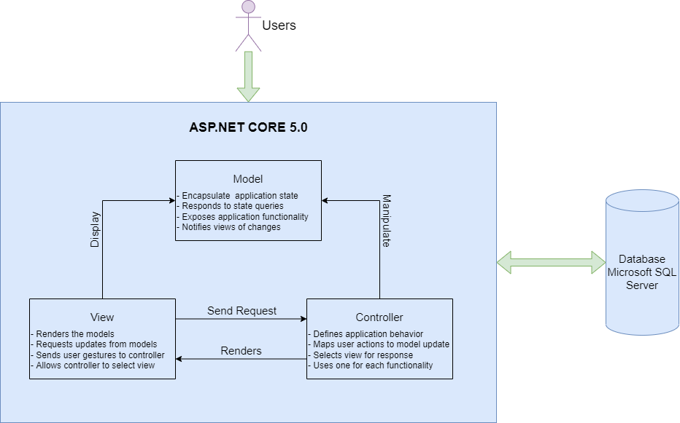

# Algorith - Data Flowchart

## Symbol:



## Main data flowchart for users

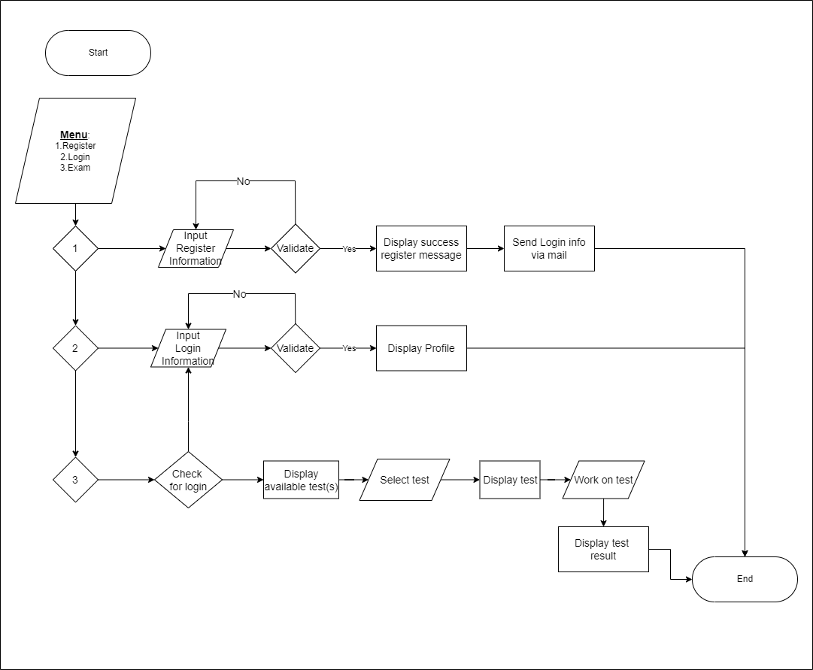

## Login Process (for admins & users)

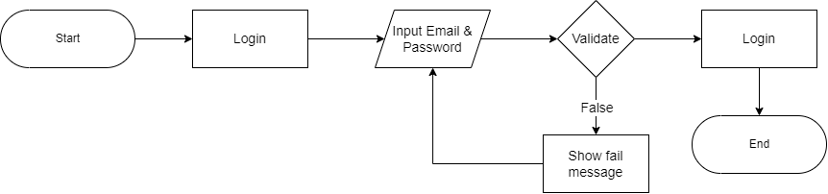

## Logout Process (for admins & users)



## Insert User (for admins & users)

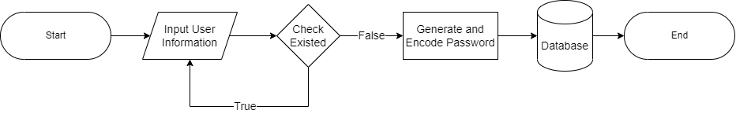

## Update user’s information (for admins & users)

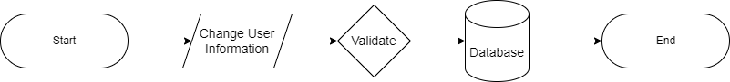

## Create Exam (for admins)

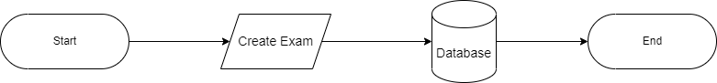

## Create Question Group (for admins)

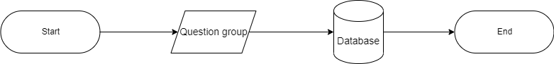

# Use Case Diagram

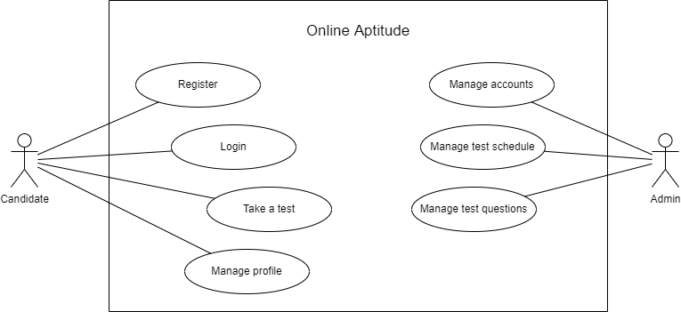

## Admin

Candidate

# Entity Relation Diagram

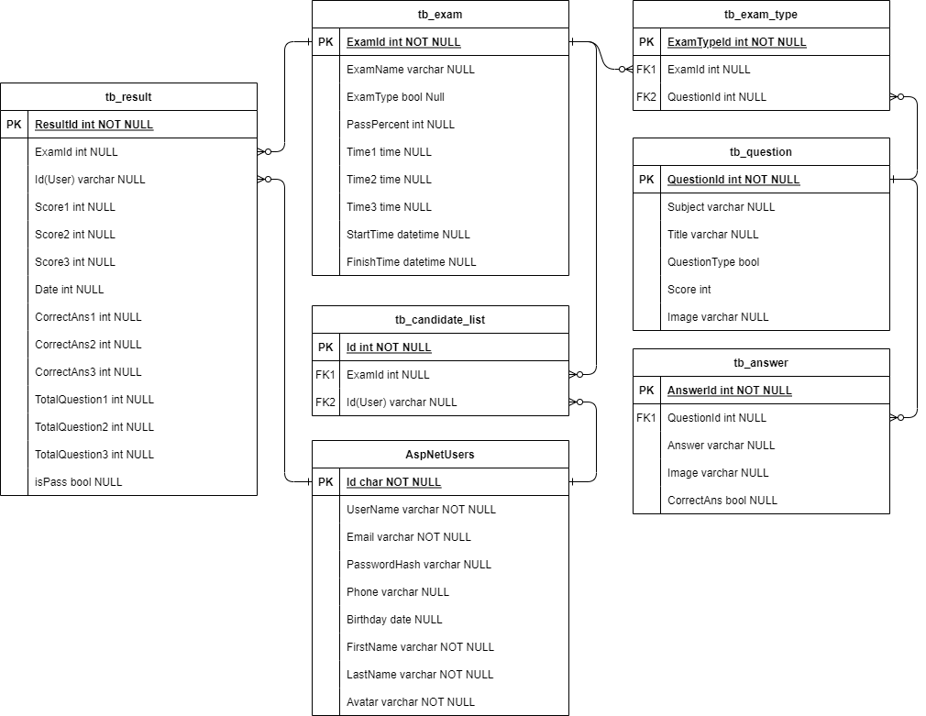

|  |  |  |  |  |  |  |  |
| --- | --- | --- | --- | --- | --- | --- | --- |
| **Project Ref. No.:** | | **Project Title:** | **Activity Plan** **Prepared** **By:** | **Date of Preparation of Activity Plan:** | | | |
| **Sr.No.** | **Task** | **Actual Start** **Date** | **Actual** **Days** | **Team** **Mate** **Names** | **Status** |
| 1 | Architecture & Design of Project | Webster  Online Aptitude | Thiện | 23/12/2021 | 1 | All Member | Completed |
| 2 | Algorithms – Data Flowchart | 23/12/2021 | 3 | All Member | Completed |
| 3 | Data Flow Chart | 23/12/2021 | 3 | All Member | Completed |
| 4 | Use Case Diagram | 23/12/2021 | 3 | All Member | Completed |
| 5 | Entity-Relationship Diagram | 23/12/2021 | 3 | Nhân | Completed |
| 6 | Task sheet review | 23/12/2021 | 1 | Thiện | Completed |

# Task Sheet review 2

**Review 3**

# Database Design

##### Table AspNetUsers

|  |  |  |  |  |  |  |  |
| --- | --- | --- | --- | --- | --- | --- | --- |
| No. | Field Name | Data Type | Null | Default | Key | Reference Table | Description |
| 1 | Id | varchar | No |  | PK |  | User’s ID |
| 2 | UserName | varchar | No |  |  |  | User’s username |
| 3 | Email | varchar | No |  |  |  | User’s Email |
| 4 | PasswordHash | varchar | No |  |  |  | User’s Hashed Password |
| 5 | Phone | varchar | Yes |  |  |  | User’s Phone Number |
| 6 | Birthday | date | Yes |  |  |  | User’s Birth Day |
| 7 | FirstName | varchar | No |  |  |  | User’s first name |
| 8 | Last Name | varchar | No |  |  |  | User’s last name |
| 9 | Avatar | varchar | No |  |  |  | User’s profile picture |

##### Table tb_candidate_list

|  |  |  |  |  |  |  |  |
| --- | --- | --- | --- | --- | --- | --- | --- |
| No. | Field Name | Data Type | Null | Default | Key | Reference Table | Description |
| 1 | Id | int | No | Identity(1,1) | PK |  | Candidate’s ID |
| 2 | ExamId | varchar | No |  | FK | tb_Exam | Exam’s ID |
| 3 | Id | varchar | No |  | FK | AspNetUsers | User’s ID |

##### Table tb_exam

|  |  |  |  |  |  |  |  |
| --- | --- | --- | --- | --- | --- | --- | --- |
| No. | Field Name | Data Type | Null | Default | Key | Reference Table | Description |
| 1 | ExamId | int | No | Identity(1,1) | PK |  | Exam’s ID |
| 2 | ExamName | varchar | No |  |  |  | Exam’s name |
| 3 | ExamType | bit | No |  |  |  | Exam’s type |
| 4 | PassPercent | int | No |  |  |  | Minimum int as pass percent |
| 5 | Time1 | time | No |  |  |  | Amount of time allocate for first part of exam |
| 6 | Time2 | time | No |  |  |  | Amount of time allocate for second part of exam |
| 7 | Time3 | time | No |  |  |  | Amount of time allocate for third part of exam |
| 8 | StartTime | datetime | No |  |  |  | Exam’s start time |
| 9 | FinishTime | datetime | No |  |  |  | Exam’s finish time |

##### Table tb_exam_type

|  |  |  |  |  |  |  |  |
| --- | --- | --- | --- | --- | --- | --- | --- |
| No. | Field Name | Data Type | Null | Default | Key | Reference Table | Description |
| 1 | ExamTypeId | int | No | Identity(1,1) | PK |  | Exam type’s ID |
| 2 | ExamId | varchar | No |  | FK | tb_exam | Exam’s ID |
| 3 | QuestionId | int | No |  | FK | tb_question | Question’s ID |

##### Table tb_question

|  |  |  |  |  |  |  |  |
| --- | --- | --- | --- | --- | --- | --- | --- |
| No. | Field Name | Data Type | Null | Default | Key | Reference Table | Description |
| 1 | QuestionId | int | No | Identity(1,1) | PK |  | Question’s ID |
| 2 | Subject | varchar | Yes |  |  |  | Question’s subject |
| 3 | Title | varchar | No |  |  |  | Question’s title |
| 4 | Score | int | Yes |  |  |  | Question’s score |
| 5 | Image | varchar | Yes |  |  |  | Question’s image |

##### Table tb_answer

|  |  |  |  |  |  |  |  |
| --- | --- | --- | --- | --- | --- | --- | --- |
| No. | Field Name | Data Type | Null | Default | Key | Reference Table | Description |
| 1 | AnswerId | int | No | Identity(1,1) | PK |  | Answer’s Id |
| 2 | QuestionId | int | No |  | FK | tb_question | Question’s Id |
| 3 | Answer | varchar | No |  |  |  | Answer’s content |
| 4 | CorrectAns | bool | No |  |  |  | Correct answer |

##### Table tb_result

|  |  |  |  |  |  |  |  |
| --- | --- | --- | --- | --- | --- | --- | --- |
| No. | Field Name | Data Type | Null | Default | Key | Reference Table | Description |
| 1 | ResultId | int | No | Identity(1,1) | PK |  | Result’s Id |
| 2 | ExamId | int | Yes |  | FK | tb_exam | Exam’s Id |
| 3 | Id(User) | varchar | Yes |  | FK | AspNetUsers | User’s Id |
| 4 | Score1 | int | Yes |  |  |  | Score of first part |
| 5 | Score2 | int | Yes |  |  |  | Score of second part |
| 6 | Score3 | int | Yes |  |  |  | Score of third part |
| 7 | Date | datetime | Yes |  |  |  | Date taken |
| 8 | CorrectAns1 | int | Yes |  |  |  | No. of correct answer first part |
| 9 | CorrectAns2 | int | Yes |  |  |  | No. of correct answer second part |
| 10 | CorrectAns3 | int | Yes |  |  |  | No. of correct answer third part |
| 11 | TotalQuestion1 | int | Yes |  |  |  | Total question first part |
| 12 | TotalQuestion2 | int | Yes |  |  |  | Total question second part |
| 13 | TotalQuestion3 | int | Yes |  |  |  | Total question third part |
| 14 | isPass | bit | Yes |  |  |  | Pass or not |

# Site map

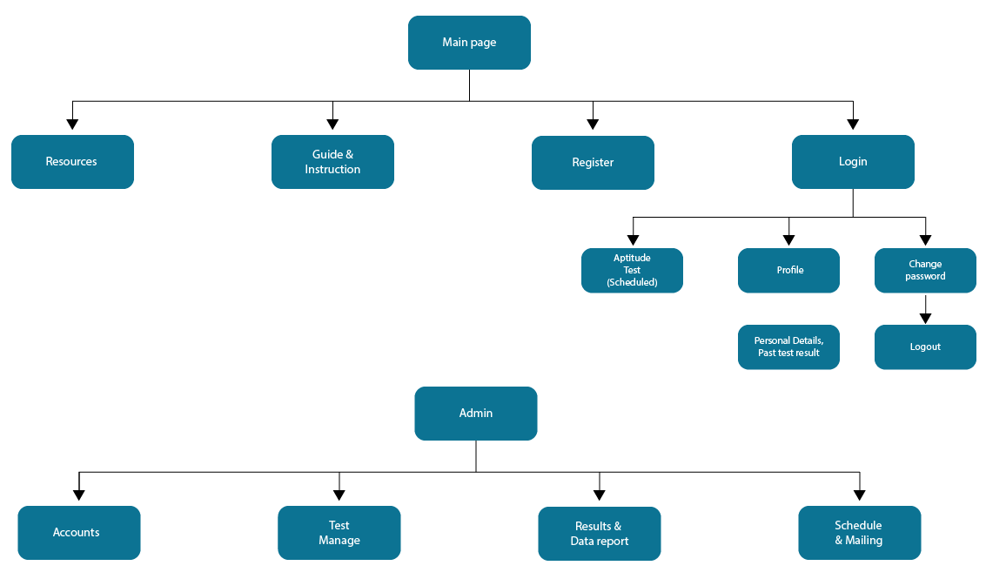

# Source code structure

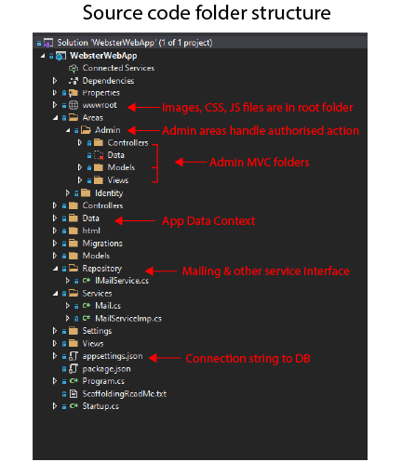

Database software: Microsoft SQL Server Management Studio 18

## Connection string

"ConnectionStrings": {

"ConnectDB": "server=User-PC;database=WebsterDB;uid=sa;pwd=password "

},

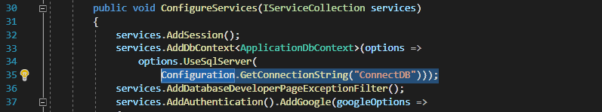

# GUI Design

## Homepage

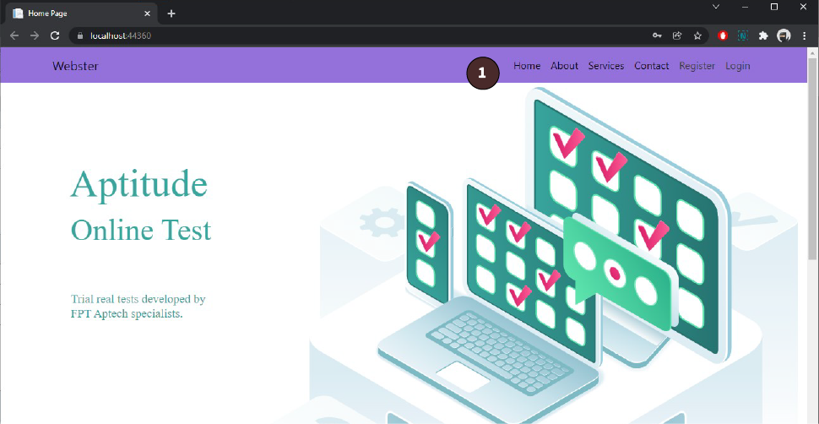

|  |  |  |  |  |
| --- | --- | --- | --- | --- |
| No. | Name | Type | Event | Description |
| 1 | Navigation bar | Hyperlink | Click | Choose and click to go to respective pages |

Home Page scrolled down

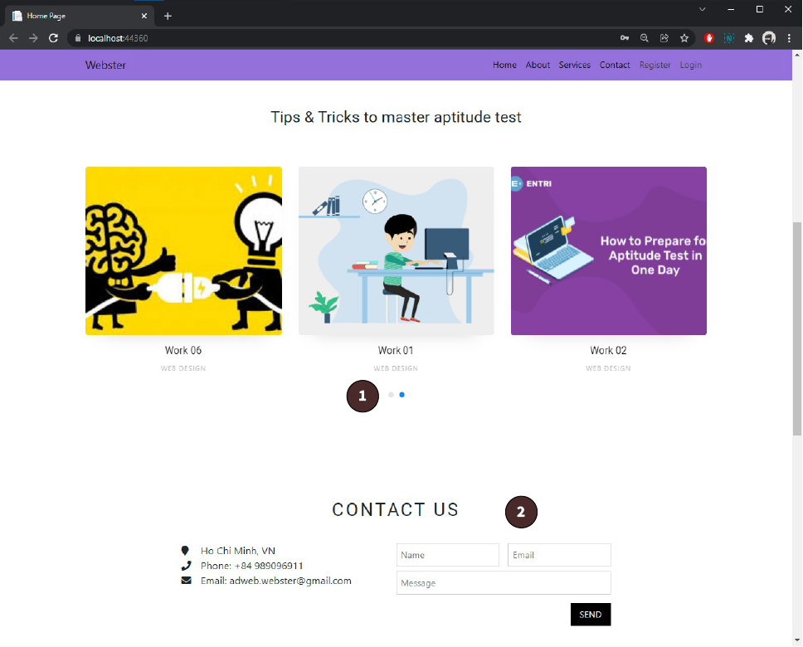

|  |  |  |  |  |
| --- | --- | --- | --- | --- |
| No. | Name | Type | Event | Description |
| 1 | Carousel | Hyperlink | Click | Choose and click to go to respective pages |
| 2 | Contact form | Textbox | Input | Fill in the text box and press Send as an email. |

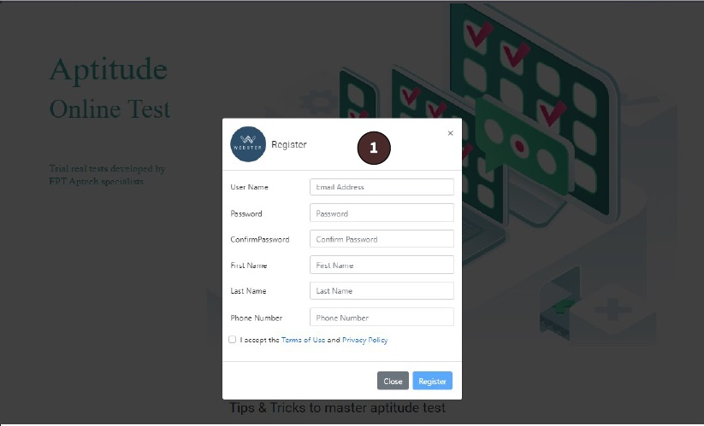

|  |  |  |  |  |
| --- | --- | --- | --- | --- |
| No. | Name | Type | Event | Description |
| 1 | Register modal form | Form | Focus | Fill in the form and submit to Register |
| 2 | Login modal form | Form | Focus | Fill in the text box and submit to Login |

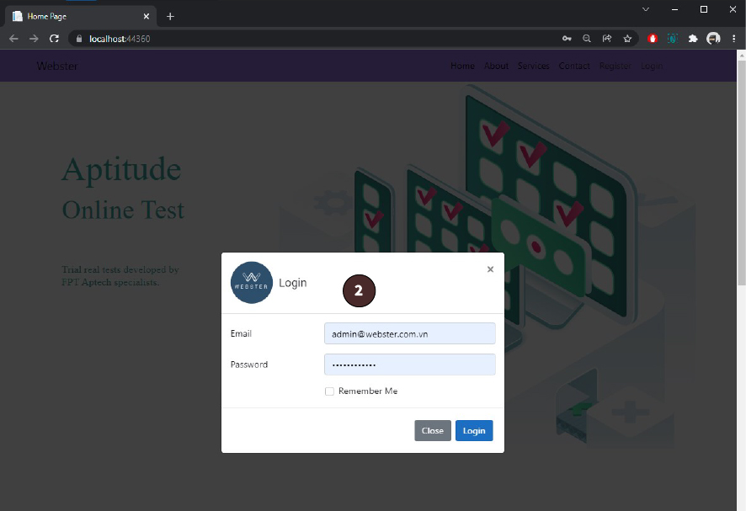

## 2.1 Online-Test Interface - Admin

Viewing test progress after logging in as admin

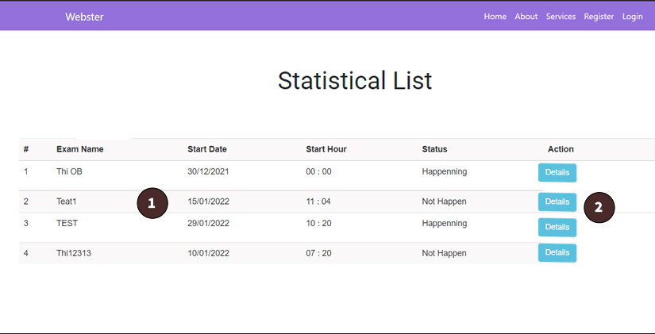

|  |  |  |  |  |
| --- | --- | --- | --- | --- |
| No. | Name | Type | Event | Description |
| 1 | List of tests | List | Details | Overview of test progress |
| 2 | Details button | Button | Click | Press button to view stats |

Continuing from viewing test progress as admin.  
Below is the interface of each test detail.

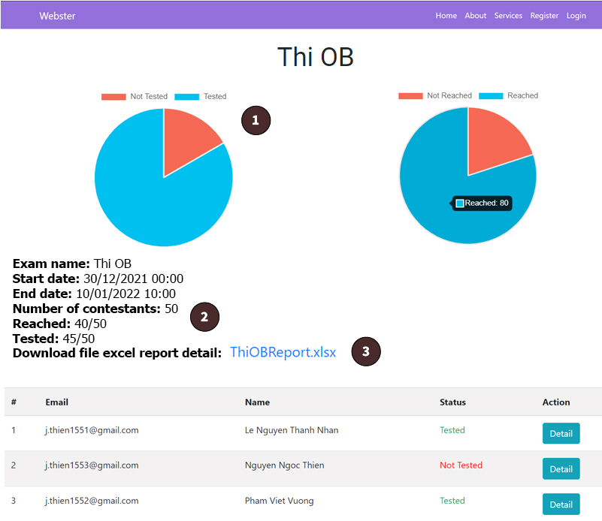

|  |  |  |  |  |
| --- | --- | --- | --- | --- |
| No. | Name | Type | Event | Description |
| 1 | Charts | Pie chart | Visual | Graphic visual of data |
| 2 | Details | Text | Display | Description of test and candidates |
| 3 | File Download | Link | Click | Click to download file |

## 2.2 Online-Test Interface – Candidate

Viewing test option after logging in as candidate

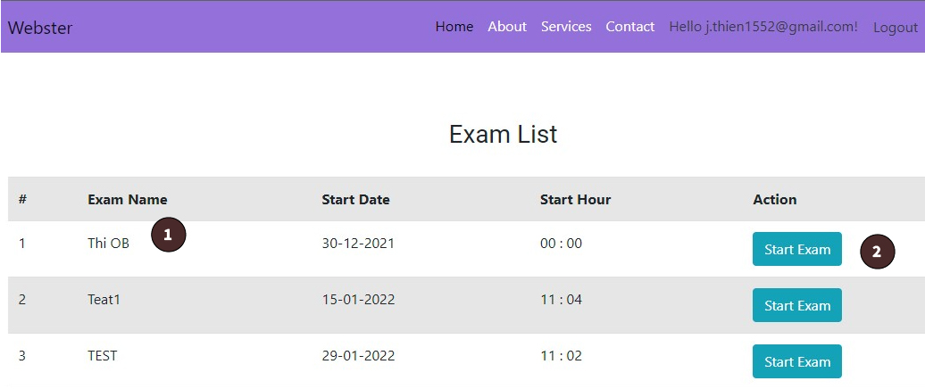

|  |  |  |  |  |
| --- | --- | --- | --- | --- |
| No. | Name | Type | Event | Description |
| 1 | Exam Details | Text | Display | Exam Details |
| 2 | Start Exam | Link | Click | Click to start the exam |
| 3 | General Knowledge Button | Link | Click | Click to start the exam |

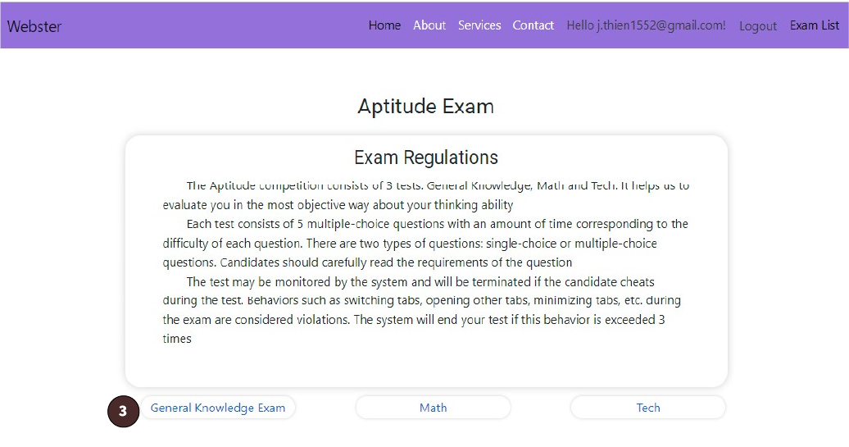

Test’s preface. Candidate start the test by click on ‘General Knowledge Exam’ button.

Test interface for candidate

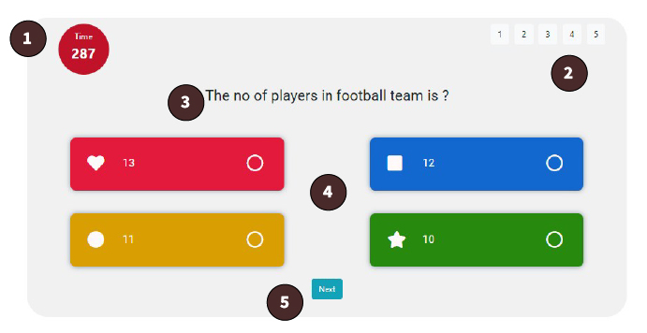

|  |  |  |  |  |
| --- | --- | --- | --- | --- |
| No. | Name | Type | Event | Description |
| 1 | Timer | Clock | Countdown | Amount of time for each part of test |
| 2 | Pagination | Button | Click | Press to view respective question |
| 3 | Question’s title | Text | Display | Test’s question |
| 4 | Answer button | Button | Click | Choosing |
| 5 | Next button | Button | Click | Press to go to next question |

Test result interface for candidate



|  |  |  |  |  |
| --- | --- | --- | --- | --- |
| No. | Name | Type | Event | Description |
| 1 | Charts | Pie chart | Visual | Graphic visual of data |
| 2 | Details | Text | Display | Description of candidate’s test result |

## 3.1 Admin Pages

Admin pages for handling Online Test Question, Exams and Users Accounts.

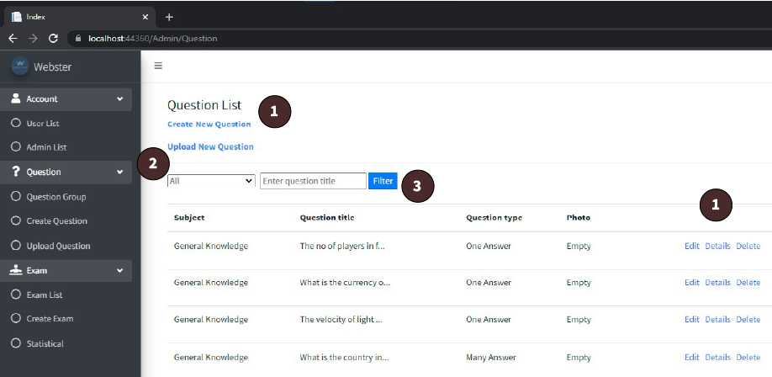

|  |  |  |  |  |
| --- | --- | --- | --- | --- |
| No. | Name | Type | Event | Description |
| 1 | Create / Edit / Details / Delete | Button | Click | Open relevant page for CRUD operation |
| 2 | Upload | Button | Click | Open page to upload file |
| 3 | Search / Filter | Text Box | Focus | Search for question’s keyword |

Upload online test question as file.

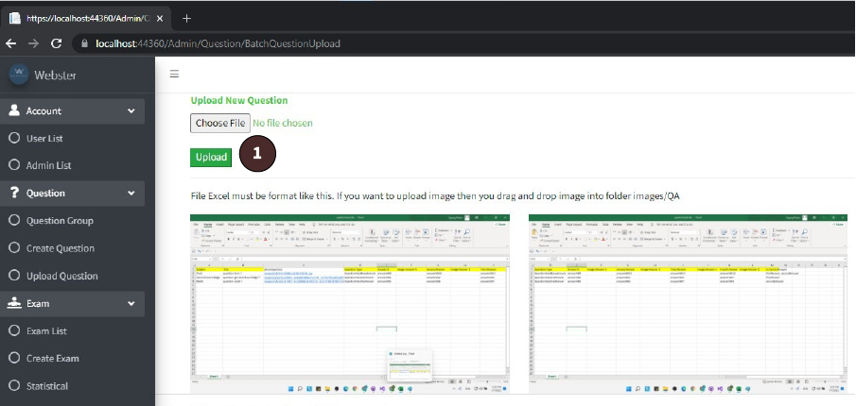

|  |  |  |  |  |
| --- | --- | --- | --- | --- |
| No. | Name | Type | Event | Description |
| 1 | Upload | Button | Click | Click to choose file for upload. |

Update test’s question

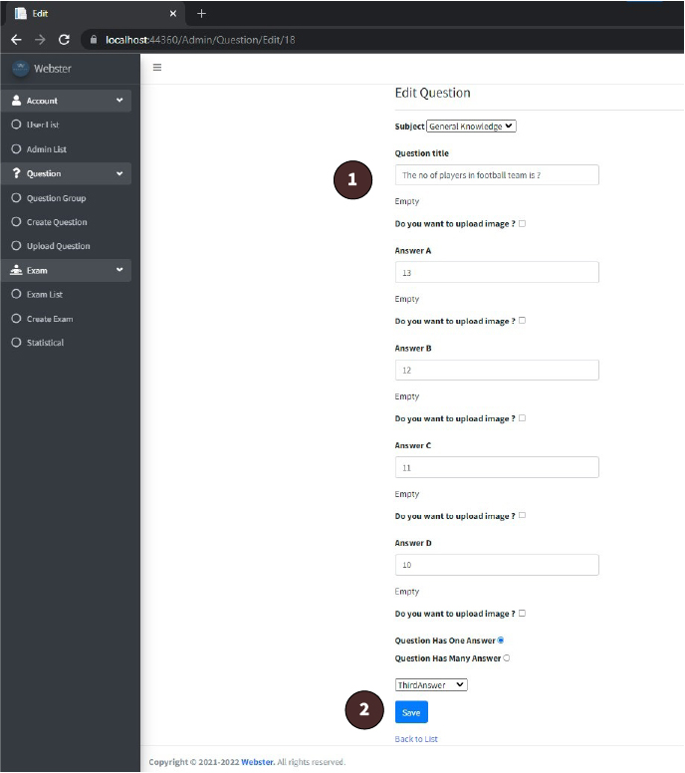

|  |  |  |  |  |
| --- | --- | --- | --- | --- |
| No. | Name | Type | Event | Description |
| 1 | Textbox | Textbox | Input | Input text to update |
| 2 | Save | Button | Click | Click to update test’s question |

Create exam

|  |  |  |  |  |
| --- | --- | --- | --- | --- |
| No. | Name | Type | Event | Description |
| 1 | Textbox | Textbox | Input | Input text to create exam |
| 2 | Checkbox | Checkbox | Click | Click to choose exam’s type |
| 3 | Create | Button | Click | Click to create an exam |

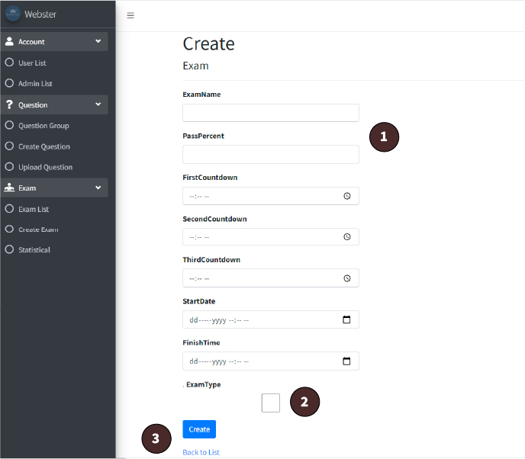

Create Exam Set

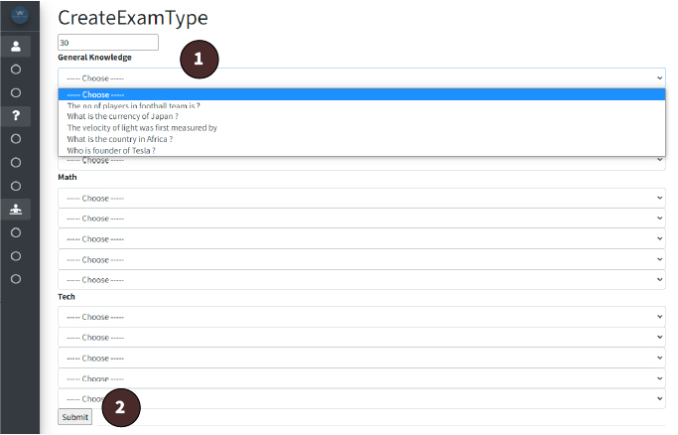

|  |  |  |  |  |
| --- | --- | --- | --- | --- |
| No. | Name | Type | Event | Description |
| 1 | Select box | Select box | Click | Click to select question for exam set |
| 2 | Submit | Button | Click | Click to create an exam set |

# Check List

|  |  |  |  |  |  |  |
| --- | --- | --- | --- | --- | --- | --- |
| **TASK** | **ASSIGNED TO** | **PROGRESS** | **START** | **END** | **DAYS** | **Path** |
| User Identity Management | Thiện | Complete | 12-27-21 | 1-2-22 | 7 | localhost:44360/Identity/Account/Manage |
| Admin generate user account | Complete | 1-2-22 | 1-3-22 | 2 | localhost:44360/Admin/Admin/Create |
| User Account Management | Complete | 1-3-22 | 1-5-22 | 3 | localhost:44360/Admin/Admin/UserList |
| Send mail (contact form & after account creation) | Complete | 1-5-22 | 1-7-22 | 3 | localhost:44360/ |
| Admin CRUD operations & view | Complete | 1-7-22 | 1-9-22 | 3 | localhost:44360/Admin/Admin/AdminList ../Admin/Admin/CreateAdminAccount |
| CRUD operations for test questions | Vương | Complete | 12-27-21 | 1-6-22 | 11 | localhost:44360/Admin/Question localhost:44360/Admin/Question/Create localhost:44360/Admin/Question/Edit/1 localhost:44360/Admin/Question/Details/1 |
| Upload questions with Excel | Complete | 12-26-21 | 12-27-21 | 2 | ../Admin/Question/BatchQuestionUpload |
| Home page design | Complete | 12-25-21 | 12-27-21 | 3 | localhost:44360/ |
| CRUD operations for exam period (Datetime, add candidate) | Tâm | Complete | 12-27-21 | 1-6-22 | 11 | localhost:44360/Admin/Exam localhost:44360/Admin/Exam/Edit/1 localhost:44360/Admin/Exam/UserList/1 localhost:44360/Admin/Exam/Details/1 |
| Mailing candidate exam date & password | Complete | 1-6-22 | 1-8-22 | 3 |  |
| Exam test functionalities: timer, exam room, password check, exam date time. Display test & record answer | Nhân | Complete | 12-27-21 | 1-3-22 | 8 | localhost:44360/Exam/ExamRoom localhost:44360/Exam/StartExam?type=1 |
| Statistic & report | Complete | 1-3-22 | 1-5-22 | 3 | localhost:44360/Admin/Statistique/index ../Admin/Statistique/Detail?ExamId=1 ../Admin/Statistique/Report?Examid=1 |
| Check test question, pass student | Complete | 1-5-22 | 1-7-22 | 3 | localhost:44360/Admin/Statistique/Detailuser |
| Test result & mailing | Complete | 1-7-22 | 1-9-22 | 3 | localhost:44360/Exam/ExamResult |
| Test history page, exam list | Complete | 1-9-22 | 1-11-22 | 3 | localhost:44360/Exam/ExamList localhost:44360/Exam/ExamHistoryList |

# Task Sheet review 3

|  |  |  |  |  |  |  |  |
| --- | --- | --- | --- | --- | --- | --- | --- |
| **Project Ref. No.:** | | **Project Title:** | **Activity Plan** **Prepared** **By:** | **Date of Preparation of Activity Plan:** | | | |
| **Sr.No.** | **Task** | **Actual Start** **Date** | **Actual** **Days** | **Team** **Mate** **Names** | **Status** |
| 1 | Database Structure | Webster  Online Aptitude | Thiện | 03/01/2022 | 1 | Nhân | Completed |
| 2 | GUI Design Front End | 05/01/2022 | 2 | All Member | Completed |
| 3 | GUI Design Back End | 05/01/2022 | 2 | All Member | Completed |
| 4 | Site map | 01/01/2022 | 1 | Thiện | Completed |
| 5 | Test plan / Test case | 05/01/2022 | 2 | Vương | Completed |
| 6 | Submission of checklist | 05/01/2022 | 1 | Thiện | Completed |
| 7 | Task sheet review | 03/01/2022 | 1 | Thiện | Completed |